MINUTES
Nyack Climate Smart Committee Meeting
October 6, 2026

Attendance: Harry Vetter, Ian Graham, Andy Stewart, Glenn Sungela, Steve Cea, Marcy Denker, Paul Henjes, Michele Gorla, Vicki Michele, Kelly Rames, John Cavuto, Peggy Kurtz

Updates and Announcements
1.Leave the Leaves Event: A fun, educational, community event at Dana Harkriders property about ecological fall landscaping methods will include Nyack CSC, Tree Committee and Nyack2030 partners.
LEAVE THE LEAVES… BUT WHERE?
A Practical Guide to Fall Yard Cleanup
Join Nyack Pollinator Pathway, the Nyack Tree Project and a host of gardening amateurs, experts and novices for a practical, hands-on conversation about what to do with all those autumn leaves while still protecting the insects, pollinators, and other wildlife that depend on leaf litter for food, shelter, and overwintering habitat.
Sunday, November 8 | 1:00–2:30 PM
170 N. Franklin Street, Nyack
Rain date: Sunday, November 1
2. Food Scraps
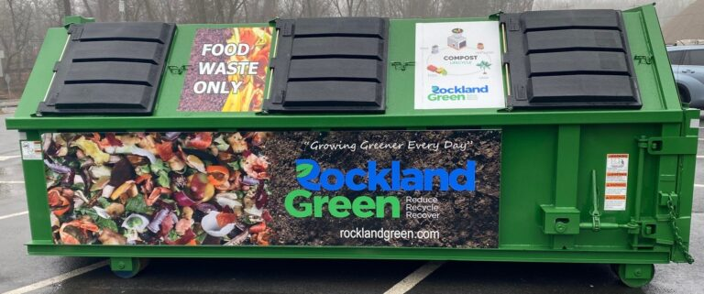
Curbside food scrap pilot program. There has been no progress for several months as we wait for Rockland Green’s director to review the project narrative.
DPW Dropoff Nyack DPW is planning to obtain a big container for the food waste like the ones the town’s use. In addition, plans are underway to remove paving in front of the food waste drop off area and create a big planting bed for trees and a pollinator garden.

3. Middle School Annual Redhawk Health Fair
Nyack 2030 will have at least two tables again at the second annual Redhawk Health Fair. Steve will host a table on energy topics, Kelly and John will host one on food waste. The Nyack Tree Committee may also host a table.
Date: October 28 Time: 6:00 PM–8:00 PM Location: Nyack Middle School

4. The Rockland Chapter of Beyond Plastics has requested support in their efforts promoting a “Skip the Stuff” law whereby businesses would provide single-use food ware when customers request them, rather than automatically putting them in every order. The waste working groups and other members agreed to support this effort by helping with a draft law to present to Andy and the Village for consideration.
5. Energy Savings Expo
The committee discussed the format, topics, location, and dates for a winter event focused entirely on energy that would combine two panel discussions and an expo with presenters at 12 or so tables.
Actions:
Steve will check which of these dates will be available at the Angel: Feb 10, or 24 or March 3 or 4. Steve, Andy, March and others who are interested will visit the space and develop plans for using the rooms.
Steve and Marcy will amend the draft topic descriptions and organization based on the committee’s discussion.
Marcy will contact Matt Mariconi about O&R’s involvement.
Steve will contact Nexamp about their involvement.
The updated chart will be circulated for further refinement, and it’s anticipated that some committee members will be the subject matter experts tabling or on one of the panels.
Marcy is to collect names of suggested contractors and recommendations from community members with successful projects to consider for the panels.

